**Pneumonia Detection**

**Phase 2:**

In Phase 2 of our project, we focused on achieving three essential goals.

1. Training our dataset on multiple models
2. Monitoring and evaluating potential Training and Testing accuracy
3. Generating potential Confusion Matrices for each model used

**DATA:**

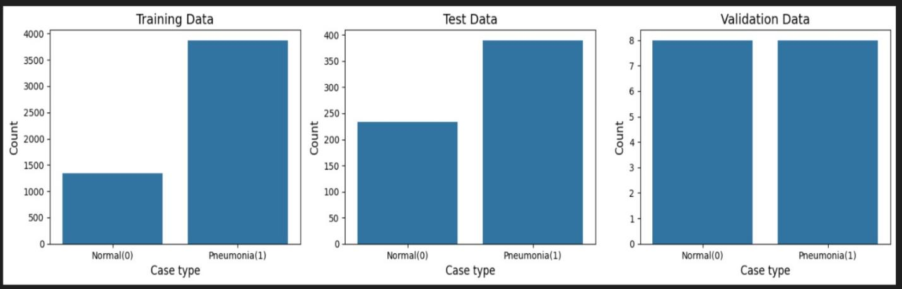

**Training our dataset on multiple models:**

To achieve this task, we focused on training our dataset on three potential models. Keeping in line with our Course Instructors Instructions we utilized potential pre-created models and further, for optimization purposes added some features (including further layers) by our own in the hopes of achieving greater and more useful results. Hence, the 3 models that we used are:

1. Convolutional Neural Networks:

This basically makes use of a series of convolutional/pooling layers to extract vital features from our pneumonia image dataset and then use these to classify or detect objects.

1. VGG 16:

A further variant of the convolutional neural network which has basically 16 layers, 13 of which are convolutional and 3 are fully connected. These aspects can be further optimized in order to generate better results.

1. ResNet-50:

Also known as Residual Network that essentially utilizes precision-based training and is also used to train the image dataset.

**Monitoring and evaluating potential Training and Testing accuracy:**

**CNN:**

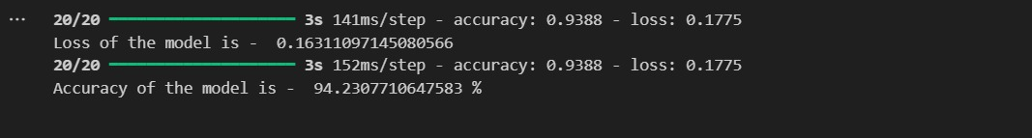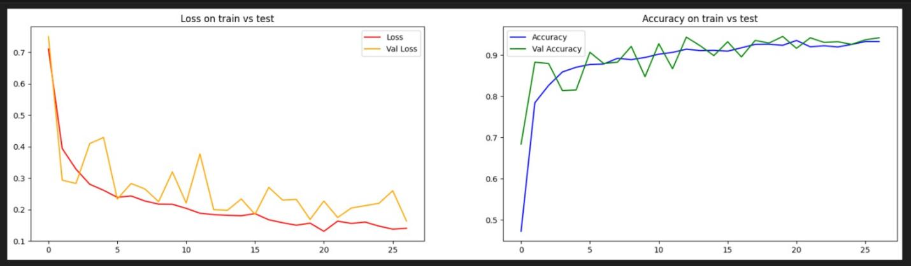

**VGG:**

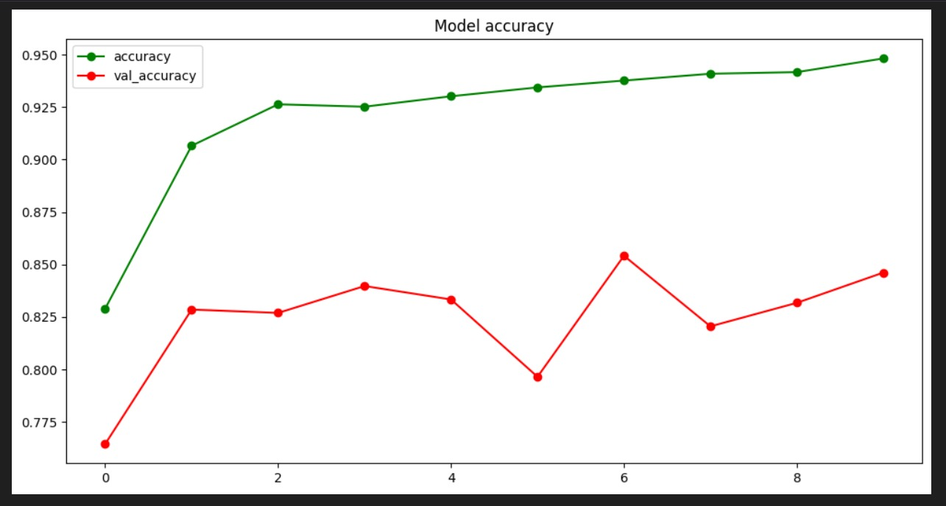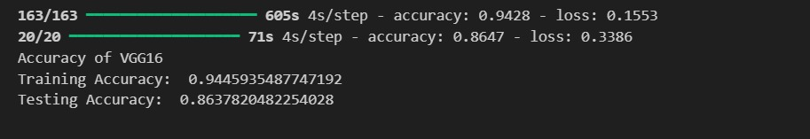

**RESNET :**

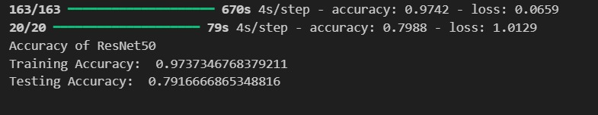

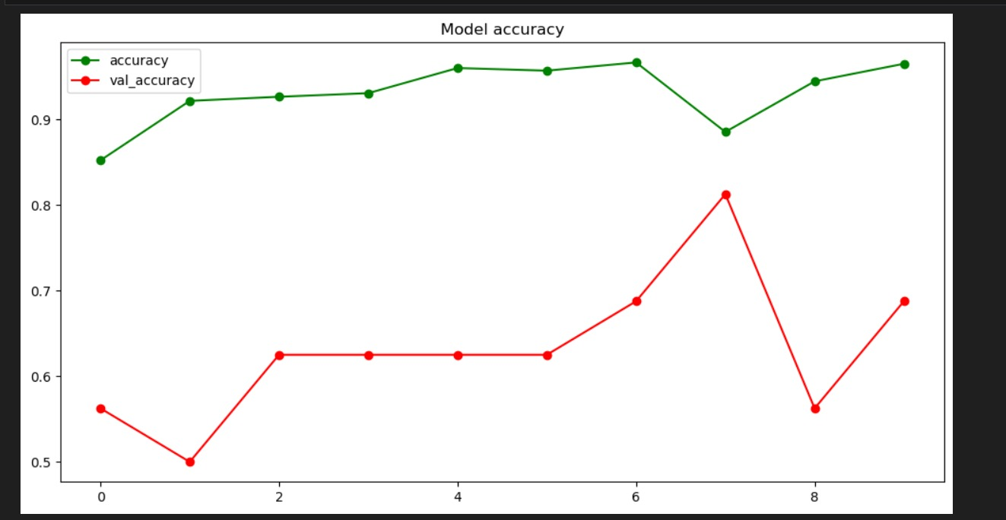

**Generating potential Confusion Matrices for each model used**

**CNN:**

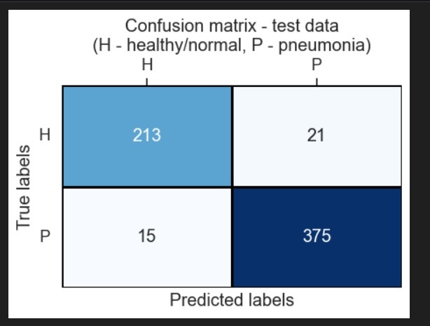

**VGG:**

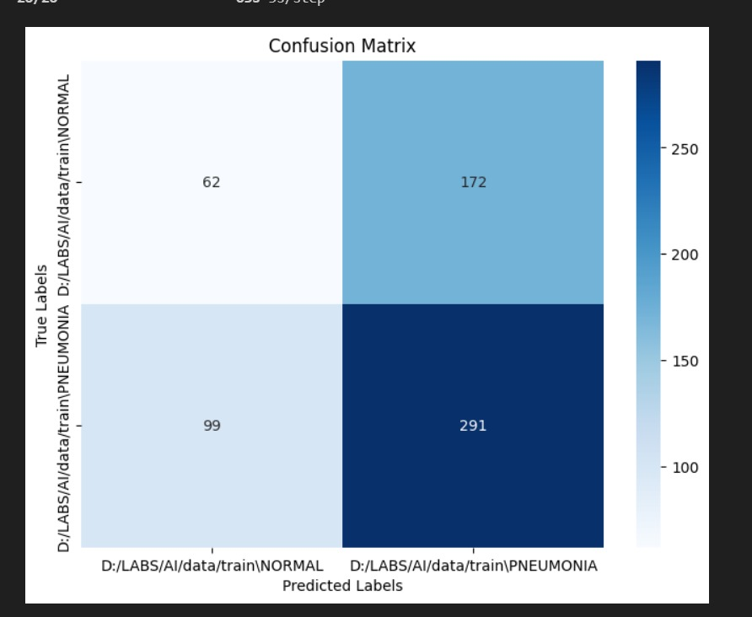

**RESNET:**

**Approach:**

The approach that we have followed during the project was that first we made sure to import all the essential libraries that would be necessary to accomplish our task. After which we made sure to identify how we were going to access our actual dataset (which was all the images).

This was possible primarily due to the fact that our dataset had already come split up into the particular portions of “training”, “testing” and “valid”. Once this particular task was done, we moved onto the next task which was classifying our images.

This aspect of the project was done before the training of each of our models. This was accomplished by storing or mentioning how many classes our images existed in. For this particular dataset the data was divided into or could be specified into 2 classes, either a “**NORMAL”** X-ray or one that has **“PNEUMONIA”**.

Followed by this we focused on applying pre-processing mechanisms on our dataset so that we could prepare the dataset i.e. our images so that we can train our models. Following this we focused our direction towards training our particular models.

Each of our three models were utilized by further applying some enhancements on some of the layers to see if we could achieve better accuracy results. Followed by which came the process of training each of our models within certain batches of data and using certain number of epochs.

Once our models were trained, we each by each made sure to measure our Testing and Training accuracy and plot these results using the respective libraries. Followed by which we made way towards creating our Confusion Matrices which would further serve as a representation of our respective results.